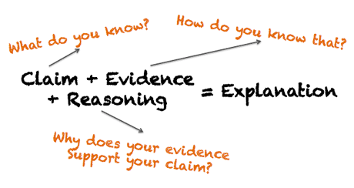

Question | Write the question that is being debated. | I wrote this at the top of my paper____________
Claim | I answered the debatable question as the LAST sentence in my intro. | I wrote my claim and highlighted it in blue____
Evidence from Text  ( start new paragraph) | - The article states  - Evidence from the article states  - According to the article | I found evidence from the text to prove my claim____  I highlighted the evidence in green_____
Reasoning #1 | - This proves ____because_____  - This supports my claim because  - This shows that _____ is _____ because  - If _____then________ | I explained why the evidence I shared proves my point in my own words or I gave an example______  I highlighted my reasoning in pink______
Evidence from Text | - The article also states  - Another piece of evidence is  - Additional evidence says that | I found evidence from the text to prove my claim____  I highlighted the evidence in green_____
Reasoning #2 | - This also proves ____because_____  - This also supports my claim because  - This also shows that _____ is _____ because  - So, If _____then________ | I explained why the evidence I shared proves my point in my own words or I gave an example______  I highlighted my reasoning in pink______
Evidence from | - Finally the article says  - The final piece of evidence says  - Furthermore the article says | I found evidence from the text to prove my claim____  I highlighted the evidence in green_____
Reasoning | - This also proves ____because_____  - This also supports my claim because  - This also shows that _____ is _____ because  - So, If _____then________ | I explained why the evidence I shared proves my point in my own words or I gave an example______  I highlighted my reasoning in pink______
Conclusion | - To summarize ____  - Therefore it is clear that_____  - All in all _____ is ______  - To sum it up_____  - Given these facts ______ is _____ | I restated my claim using DIFFERENT words_____  I highlighted my conclusion in blue______

